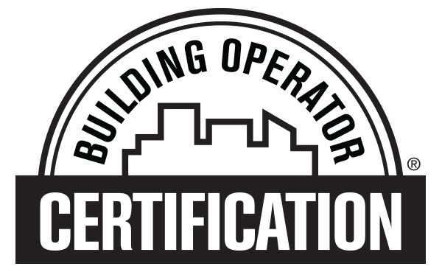

TRAINING CERTIFICATE OF COMPLETION APPLICATION

BOC LEVEL II

Please complete the following form. It is important that the NEEC BOC Credentialing Committee have substantiating data for each criterion on the application. The application should be completed and submitted regardless of coursework completion. Bring the completed form to your final BOC class or mail to: [Partners – insert instructions here for how your students should return their completed form to you (email, hand in during class, etc.) Once you have reviewed the applications for completeness and collected any missing items, submit the complete application forms to our Credential Specialist following the steps outlined in the Level II “All Class Procedures document”, ‘Last Class’ section of the document. You should retain student test and project grades for your records.] Website: www.theBOC.info.
Please allow 45 days for processing.

Credential Materials and Correspondence will be mailed to your home address unless this box is checked

ID #: _____________________ Course Location: __________________________________________________________

____Mr. ____Mrs. ____Ms. Name: __________________________________________________________________________
Employer: _______________________________ Job Title: _______________________________________________________
Work Address: ________________________________________________ Suite Number/Mail Stop:______________________
City/State/Zip: ____________________________________________________________________________________________
Phone (with Area Code): _________________________________ Fax Number:_______________________________________
Email: ______________________________________________________
Home Address: __________________________________________________________ Apt/Unit No.______________________
Home City/State/Zip: _______________________________________________________________________________________
Personal Phone (with Area Code): __________________________ Personal Email: _________________________________
My employer:
- Covers the cost of my tuition for BOC training ___ Yes ___ No ___Don’t know
- Requires me to have the BOC Level II Training Certificate of Completion (TCOC) ___ Yes ___ No ___Don’t know
- Encourages, not requires, me to have the BOC Level II TCOC ___ Yes ___ No ___Don’t know

RECOGNITION:
Individuals who earn a BOC TCOC will automatically be recognized with a BOC letter issued to the individual and to your supervisor. Please help us recognize your achievements by completing the following questions.

Supervisor Name: ___________________________ Supervisor Email: _____________________________________________
Supervisor Address: ______________________________________________________________________________________
Supervisor City/State/Zip: __________________________________________________________________________________
______Please send a news release regarding accomplishment to the following workplace newsletter editor:
Name: __________________________ Email: ___________________________________________________________________
____ I give my permission for my name to be published as a BOC credentialed operator.

ELIGIBILITY
I have met the following eligibility requirements to earn the BOC Level II TCOC:

- A technical degree and three years of experience working in operations and maintenance of a commercial or institutional facility, OR
- A union membership at journey level and three years of experience, OR
- BOC Level I Training Certificate of Completion or Certification (CBO) and four years’ experience in the operations field.
- I have earned my BOC Level I Training Certificate of Completion or Certification. All work verification documentation submitted in my Level I application is still current.
- I HAVE NOT earned a BOC Level I Training Certificate of Completion or Certification. My work experience or education is below.
(One of the above three options must be met to earn the Level II TCOC)

I have not yet met the requirements but will do so by (date): ________________________________________________________

Work Experience
Please list most current experience first and you only need to show enough to confirm years of related experience:

Dates (From-To) Employer (Name/Address) Job Title

Brief Job Description:

Dates (From-To) Employer (Name/Address) Job Title

Brief Job Description:

Education [NOTE: Complete this section only if substituting education for work experience.]

School/Training Center (Name & Location) Years Attended (from mm/yy to mm/yy)

Degree & Field of Study Graduated?

APPLICANT SIGNATURE
Having completed the application to the best of my ability, I do hereby apply for NEEC’s BOC Level II Training Certificate of Completion (TCOC). I understand I must maintain my TCOC annually starting the year following my date of completion and that 10 maintenance points are required each year for BOC Level II and if applicable will also apply to maintaining Level I or CBO. The fee is $75 and the deadline is March 31 annually.

_____________________________________________________________________________________________________________
Signature Date

THE FOLLOWING MUST BE COMPLETED BY AN IMMEDIATE SUPERVISOR OR PERSONNEL OFFICER:
Affidavit: To the best of my knowledge, I hereby attest that the employee’s work experience noted above is true and accurate:

_____________________________________________________________________________________________________________
Name Job Title Phone or Email

_____________________________________________________________________________________________________________
Signature Date

