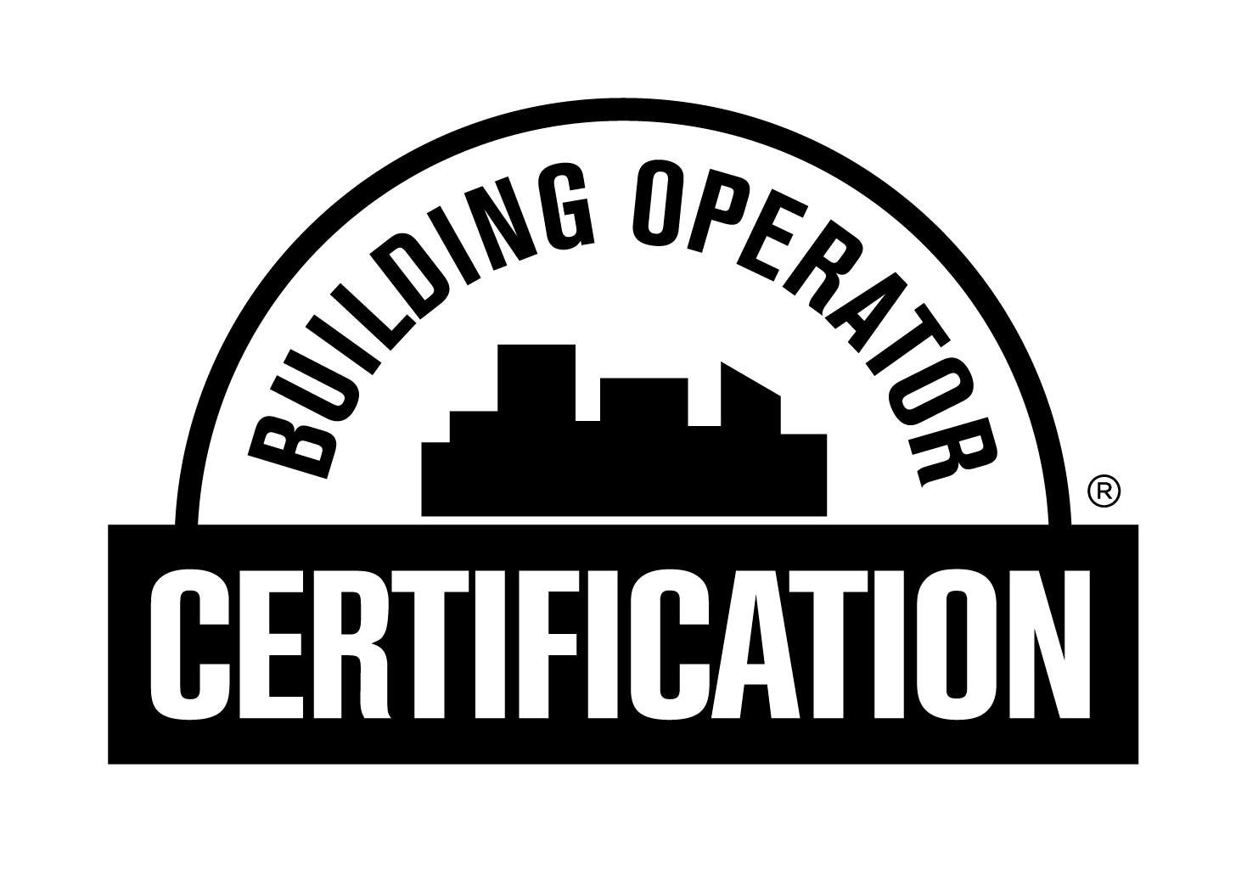

Application for Fundamentals of Energy Efficient Building Operations (FEEBO)

[Partners – insert instructions here on what your students should do with this form (i.e. bring it to the final class date, or submit it electronically to you or your course administrator). Once the applications have been reviewed to ensure they are complete, use the information gathered to populate FEEBO Certificant Partner Import Sheet.xlsx and submit to NEEC according to the instructions found on that sheet]

Course Location: _____________________________________________________

____Mr. ____Mrs. ____Ms. Name: _____________________________________________________________________
Employer: _______________________________ Job Title: __________________________________________________
Work Address: ________________________________________________ Suite Number/Mail Stop:__________________
City/State/Zip: ________________________________________________________________________________________
Phone (with Area Code): _________________________________ Fax Number:__________________________________
Email: ______________________________________________________
Home Address: _________________________________________________________ Apt/Unit No.__________________
Home City/State/Zip: __________________________________________________________________________________
Mobile Phone (with Area Code): __________________________ Personal Email: ____________________________

