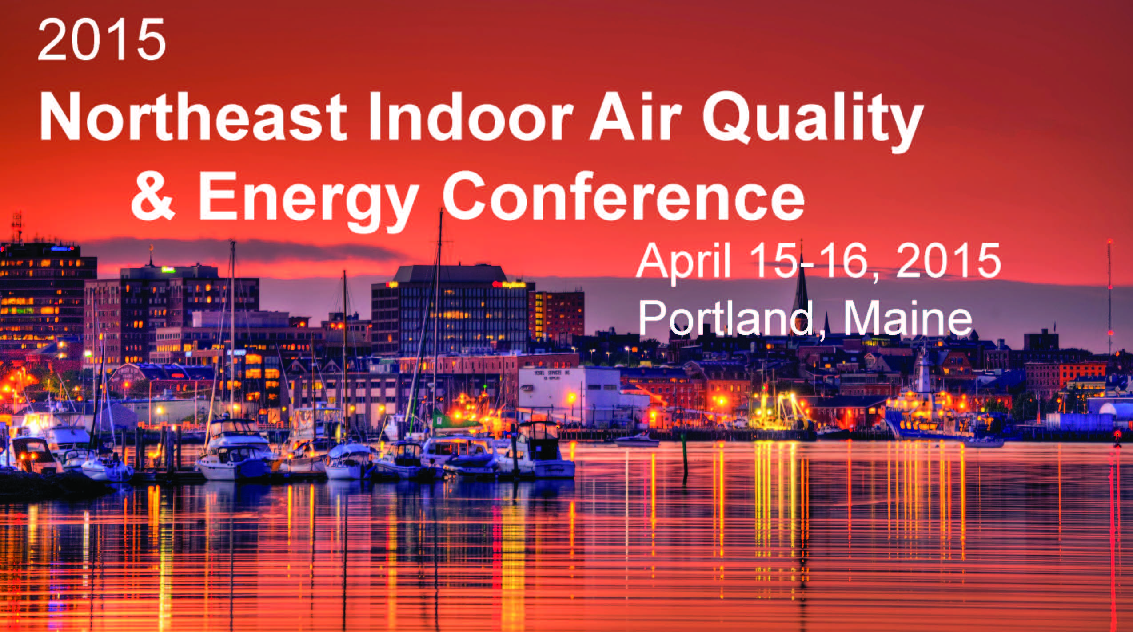

The 2015 Northeast Indoor Air Quality & Energy Conference attracts a diverse range of professionals from throughout the region and across the United States and Canada. Attendees come together to share new and proven concepts for achieving safe, healthy, and sustainable indoor environments. A variety of lectures, workshops, exhibits and poster sessions will offer important information and provide for discussions that will address professional development, scientific issues, trends, industry innovations and more. The event is also one of the IAQ industry’s premier networking opportunities and the ideal opportunity for companies who provide services and products to the industry to connect with their current and future customers. If you design, build, operate or maintain buildings, if you work in residential, educational, commercial or industrial environments, if you provide consulting and professional services, or if you manage policy or public health — this conference is for you.

Click here for conference fees and registration.

2015 IAQ & Energy Conference Highlights

Seminar Day – April 15, 2015 – 4 Half-Day Seminars

Program 1:
The Unintended Consequences of Going Green
Derrick Denis, Clark Seif Clark, Phoenix, AZ

Program 2:
Bill's Top Ten: Tips for Enhancing Both Energy Efficiency & IAQ in Schools and Commercial Buildings
William A. Turner, P.E., Turner Building Science & Design, Harrison, ME

Program 3:
The Two Faces of an IAQ Problem: Approaching an Indoor Environmental Issue from BOTH the Owner's and Practitioner's Perspectives
Bob Krell, IAQ Technologies, Inc., Syracuse, NY

Program 4:
Heat Pumps in the Residential Environment: Energy Efficiency, Applications, New Technology, & IAQ
David Hales, Washington State University Energy Program, Olympia, WA

Click here for Seminar Day Program Descriptions

Cocktail Reception (Open to the Public) – Wednesday, April 15, 2015
- 4:00pm – 7:00pm
- Door Prizes (Must be present at Reception to win!)
- Silent Auction
- Cocktail Reception and the exhibit area is OPEN to the public. No registration fee to attend the reception and visit the conference exhibits. Cash bar.

Keynote Address – April 16, 2016

“Creating Healthy Buildings for (and in) a Changing Climate: Opportunities for Advancing Indoor Air Quality and Energy Goals”
Bob Axelrad, Senior Policy Advisor and Indoor airPLUS Program Manager

Indoor Environments Division, US Environmental Protection Agency - Washington, D.C.

Over a span crossing four decades, Bob has seen the IAQ issue evolve on many fronts while remaining a largely un-mandated and under-funded area of environmental health. Bob will share his perspective on the successes, challenges, trends, and the most promising and practical near- and mid-term opportunities to advance IAQ in the context of energy efficiency, climate change, and sustainability. His presentation will touch on:
- What’s worked and what we’ve learned
- Why indoor air quality is still having to fight its way into building design, construction, retrofit and O&M projects
- Some of the most important things to make progress on in the next 5 years
- Promising models and paths for advancing -- and funding -- IAQ and energy (in New England and across the country)

Workshops! (shown in alphabetical order by title) – April 16, 2016

We have an amazing line-up of workshops presented by notable indoor environment and energy professionals from all across the country. We have sessions on energy efficiency and building design for both commercial and residential buildings, building investigations strategies, new research, ventilation strategies, building products, cutting edge systems and technologies, environmental health, and more. Click here for workshop summaries.

Answering Those Unanswered Questions on Residential Ventilation: A Controlled Energy Efficient, Effective Approach
Presenter: Kurt Johnson - Fresh Air Ventilation, Inc., Lewiston, ME.

Bad Smells and No Dog to Blame
Presenter: Steve Caulfield, P.E., CIH – Turner Building Science & Design, Harrison, ME

Black, Brown, Green and White: What You Can Learn from Stains
Presenter: Jeffrey May – May Indoor Investigations, Tyngsborough, MA

Combined Heat & Power
Presenters: Michael Chonko and Katherine Everett, SMRT

Community Scale Net Zero Energy Homes & IAQ
Karla Donnelly - Steven Winter Associates, Norwalk, CT

Designing and Building Small Houses
Presenter: Jim Bahoosh, Builder, Morrill, ME

Exposure to Allergens and Endotoxins in Homes, Schools and Workplaces: A Review of the Latest Science
Presenter: Eva M. King, MSc., PhD, Head of Immunoassay Department, Indoor Biotechnologies, Inc., Charlottesville, VA

Getting a Good Commercial Enclosure
Presenter: Terry Brennan, Principal, Camroden Associates, Westmoreland, NY

Great Ventilation: Why We Do It; How We Do It
Presenters: Barry Stephens - Zehnder America, and Fred Gordon

High Performance Homes Don't Need to Be Weird, Look Ugly, or Cost Too Much
Presenters: William A. Turner, P.E., Turner Building Science & Design, Harrison Maine and David Johnston, Builder, David Johnston & Company, Gorham, ME

Legally Defensible Mold Investigation Strategies
Presenter: Jack Springston, CIH, CSP - TRC Environmental Corporation, New York, NY

The Microbiology of Sewage: Health Risks, and Cleanup
Presenter: David Gallup - EMLab P & K, San Bruno, CA

Moisture and Humidity Control in Buildings: The New EPA Guidance
Presenters: Lew Harriman, Director of Research - Mason Grant Consulting, Portsmouth NH and Terry Brennan, Principal, Camroden Associates, Westmoreland, NY

Mold and ERMI: Comparing Traditional Investigation & Testing Methods to ERMI
Presenter: Jason Dobranic, Ph.D. – EMSL, Houston, TX

Reducing Outdoor Contaminants in Indoor Spaces Initiative: A Case Study in Expanding the Concept of Healthy Buildings
Presenters: Norman Anderson, Environmental Public Health Consultant, Winslow, ME and Linda Wigington, Linda M. Wigington and Associates

Storm Response and Restoring Contaminated Buildings
Presenter: Scott Carter, Servpro of Maine, Falmouth, ME

Toxic Content in Building Products: Pathways for Exposure and Prevention
Presenter: Jim Vallette, Senior Researcher, Healthy Buildings Network, Southwest Harbor, ME

Understanding Dust and Particulates – Getting the whole picture with Microanalysis
Jared Kelly, Laboratory Manager, EMSL - Salem, NH

Ventilation Effectiveness in Very Tight Homes
Presenter: David Hales, Building Systems & Energy Specialist, Washington State University Energy Program, Spokane, WA
________________________________________________________________________________________________________

Click here to register for the 2015 Northeast Indoor Air Quality & Energy Conference

Our Sponsors:
